Ministry of Higher Education
LANDMARK METROPOLITAN UNIVERSITY INSTITUTE (LMUI) BUEA
“Training Productive Leaders”


School: Landmark School of Science, Engineering and Technology
Department: Software Engineering
Design and Implementation of a Blockchain-based Web3 Application for Tamper-proof Land Title Verification

A Project Report Submitted in Partial Fulfilment of the Requirements for the Award of a
Bachelor of Technology (BTech) Degree in…

Presented by
BESINGI MARINUS NYANDO
(LMUI-24SWE285)

Supervisor Co-Supervisor
Mr. KAH KISSINGER Mr. KAH KISSINGER
Academic Year 2025/2026

Table of Contents
CERTIFICATION iii
DEDICATION iv
ACKNOWLEDGEMENTS v
LIST OF ABBREVIATIONS AND ACRONYMS vi
LIST OF TABLES vii
LIST OF FIGURES viii
ABSTRACT ix
CHAPTER ONE: INTRODUCTION 1
1.1 Introduction 1
1.2 Background of the Study 1
1.3 Problem Statement 3
1.4 Objectives of the Study 3
1.4.1 General Objective 3
1.4.2 Specific Objectives 3
1.5 Research Questions 4
1.6 Significance of the Study 4
1.7 Scope of the Study 5
1.8 Limitations of the Study 5
1.9 Organization of the Study 5
CHAPTER TWO: LITERATURE REVIEW 7
2.1 Introduction 7
2.2 Conceptual Review 7
2.2.1 Land Registry Systems 7
2.2.2 Blockchain Technology 7
2.2.3 Web3 Applications 8
2.2.4 Smart Contracts 8
2.3 Review of Related Works 9
2.4 Proposed Solution 14
2.4.1 Summary of Research Gap 14
2.4.2 Solution 14
CHAPTER THREE: SYSTEM ANALYSIS AND DESIGN 15
3.1 Introduction 15
3.2 Development methodology 15
3.2.1 Presentation of Software Methodologies 15
3.2.2 Adopted Methodology 15
3.3 Tools and Materials Used 16
3.3.1 Hardware Requirements 16
3.3.2 Software Requirements 17
3.4 System Modules 17
3.5 System Analysis 18
3.5.1 Functional Requirements 18
3.5.2 Non-Functional Requirements 19
3.5.3 Cost Evaluation 19
3.5.4 Project Schedule 20
3.5.5 Use Case Analysis 20
3.5.6 Sequence Diagram(s) 21
3.5.7 Activity Diagram 23
3.6 System Design 25
3.6.1 System Architecture 25
3.6.3 Class Diagram 27
3.6.4 Entity-Relationship Diagram 28
3.6.5 Data Dictionary 30

CERTIFICATION

This is to certify that this Project Report, written and presented to Landmark Metropolitan University Institute by Besingi Marinus Nyando in partial fulfilment of the requirements for the award of a Bachelor of Technology (BTech) Degree in Software Engineering is original and suitable for public presentation.

STUDENT

………………………………

DATE ……………………….

SUPERVISOR

………………………………

DATE …………………………

DATE …………………………
CO-SUPERVISOR

………………………………

DEDICATION

To my family, friends, and the university institute.

ACKNOWLEDGEMENTS

Profound gratitude to GOD for the strength to go through a season that has been transformational to me as a person, The university institute for every support and guidance, My Parents for their invaluable support throughout this journey, and not overlooking the tremendous support from my close friends who have always been there to give me the courage and motivation I needed to go through a season mark with ups and downs.

LIST OF ABBREVIATIONS AND ACRONYMS

- BTech: Bachelor of Technology
- CID: Content Identifier (IPFS hash format used to retrieve files)
- CSS: Cascading Style Sheets (used for styling the web interface)
- ER Diagram / ERD: Entity-Relationship Diagram
- HTML: HyperText Markup Language
- IPFS: InterPlanetary File System (decentralized storage network used for land PDFs)
- LMUI: Landmark Metropolitan University Institute
- MINDCAF: Ministry of Property, Land Tenure and State Property
- PDF: Portable Document Format
- RAM: Random Access Memory
- SSD: Solid State Drive
- SWE: Software Engineering

LIST OF TABLES

Table 1 Development Cost 19
Table 2 Operational Cost 20
Table 3 Total Estimated Cost 20
Table 4 Project Schedule 20

LIST OF FIGURES

Figure 1 Usecase Analysis 22
Figure 2 Sequence diagram to register and verify land title 23
Figure 3 Activity diagram 24
Figure 4 Achitecture diagram 26
Figure 5 Class diagram 27
Figure 6 ER Diagram 29

ABSTRACT

Land ownership plays a critical role in economic development and social stability. However, in many developing countries like Cameroon, traditional land registries rely heavily on centralized databases and manual, paper-based records. This centralized architecture leaves the system highly vulnerable to document tampering, unauthorized record modifications, duplicate ownership claims, and widespread fraud. To address these challenges, this project presents the Design and Implementation of a Blockchain-based Web3 Application for Tamper-proof Land Title Verification.
Adopting an Agile development methodology, a decentralized application (dApp) was designed to establish a transparent, immutable, and secure land administration layer. The system architecture separates user interaction, application logic, and blockchain storage. The frontend was built using React and Tailwind CSS, communicating via the Viem library and MetaMask wallets to eliminate centralized intermediaries. Critical land registry operations, including land registration, identity mapping, ownership transfers, and dispute management, are executed autonomously using Solidity smart contracts deployed on the Ethereum blockchain environment. To overcome data storage constraints on-chain, physical land title documents are securely uploaded to the decentralized InterPlanetary File System (IPFS), which returns a unique Content Identifier (CID) hash recorded directly on the blockchain ledger.
The resulting system provides citizens and inspectors with a tamper-proof system to register land, independently verify title authenticity via unique identification numbers, and trace full historical ownership lineages. Ultimately, this project serves as a secure proof-of-concept demonstrating how emerging Web3 and distributed ledger technologies can successfully eliminate fraud, minimize boundary or title disputes, and enhance institutional transparency in land administration.

CHAPTER ONE: INTRODUCTION

1.1 Introduction
Land ownership plays a critical role in economic development, social stability, and investment. Reliable land administration systems ensure that property rights are clearly defined, legally recognized, and protected against fraud or manipulation. However, in many developing countries, land management systems still rely heavily on centralized databases and paper-based documentation, which are vulnerable to inefficiencies, corruption, and record tampering.
Recent advances in digital technologies have introduced innovative approaches to secure data management and verification. One such technology is blockchain, a decentralized and immutable digital ledger that enables secure and transparent record keeping. Blockchain has gained significant attention for its potential applications in various sectors including finance, healthcare, supply chain management, and land administration.
By integrating blockchain technology with Web3 applications and smart contracts, it becomes possible to design systems that provide tamper-resistant storage of critical records while enabling transparent verification processes. In the context of land administration, such systems can significantly reduce fraud, prevent unauthorized modification of land records, and improve trust among stakeholders.
This chapter introduces the research problem addressed in this project, outlining the objectives and significance of developing a blockchain-based Web3 application for tamper-proof land title verification. It also defines the scope and limitations of the study.

1.2 Background of the Study
Land ownership is one of the most important economic assets in many developing countries, including Cameroon. Secure land ownership allows individuals and businesses to invest confidently in property development, agriculture, and infrastructure. However, land administration
systems in many parts of the country remain largely manual and centralized, which creates opportunities for fraud, corruption, document tampering, and multiple ownership claims.
Traditional land registry systems rely on paper-based records stored in government offices. These records can be easily altered, misplaced, or destroyed, leading to frequent land disputes and fraudulent transactions. In some cases, multiple individuals may claim ownership of the same parcel of land due to manipulation of land title documents or unauthorized alterations to official records.
Emerging digital technologies provide new opportunities to address these challenges. One of the most promising technologies is blockchain. Blockchain is a distributed ledger technology that stores records in a decentralized network of computers where data is immutable, transparent, and cryptographically secured.
Unlike traditional databases controlled by a single authority, blockchain allows multiple participants to verify and validate transactions without relying entirely on a central intermediary. Once a record is written into the blockchain, it becomes extremely difficult to modify or delete it, thereby ensuring data integrity and trust.
By integrating blockchain with modern web technologies such as Web3 applications and smart contracts, it is possible to create a secure digital system for recording and verifying land ownership records. Such a system can provide tamper-proof documentation, transparent verification processes, and improved trust between land buyers, sellers, and government authorities.
This project therefore focuses on designing and implementing a blockchain-based Web3 application that enables tamper-proof verification of land title records. The proposed system aims to enhance transparency, reduce fraud, and improve the efficiency of land title verification processes.

1.3 Problem Statement
Land ownership disputes remain a major issue in Cameroon due to weaknesses in the current land administration system. The traditional land registry process has several limitations including:
- Centralized storage of land records
- Susceptibility to document tampering
- Lack of transparency in land transactions
- Inefficient verification procedures
- Loss or damage of physical documents
Because land records are stored in centralized databases or physical registries, they can be manipulated by unauthorized individuals or corrupted officials. This creates opportunities for illegal land sales, duplicate ownership claims, and fraudulent alterations of land titles.
Furthermore, verifying the authenticity of a land title often requires visiting multiple government offices, which is time-consuming and inefficient. In many cases, buyers have limited ways to independently verify whether a land document is genuine before completing a transaction.
These challenges highlight the need for a secure and transparent digital system capable of protecting land ownership records against tampering while enabling efficient verification by authorized stakeholders.

1.4 Objectives of the Study

1.4.1 General Objective
The main objective of this project is to design and implement a blockchain-based Web3 application for tamper-proof land title verification.

1.4.2 Specific Objectives
The specific objectives of the study include:
- To analyze the limitations of existing land registry systems.
- To design a blockchain-based architecture for secure land record management.
- To develop smart contracts that store and verify land title records.
- To implement a Web3-based user interface for interacting with the blockchain system.
- To evaluate the effectiveness of the proposed system in preventing data tampering and improving transparency.

1.5 Research Questions
The study seeks to answer the following questions:
- What are the major weaknesses of the existing land registry systems?
- How can blockchain technology improve the integrity of land title records?
- How can Web3 applications be used to facilitate transparent verification of land ownership?
- What system architecture can ensure secure storage and retrieval of land records?

1.6 Significance of the Study
This project is significant for several reasons.
- Firstly, it demonstrates how blockchain technology can be applied to solve real-world problems related to land ownership and property rights.
- Secondly, the system provides a tamper-resistant mechanism for storing and verifying land title records, which can help reduce fraud and land disputes.
- Thirdly, the project contributes to ongoing efforts by the government towards digital transformation, including land administration systems.
Finally, the study provides a technical framework that can be expanded into a full-scale land registry system in the future.

1.7 Scope of the Study
This project focuses on the design and development of a blockchain-based system for verifying land title records.
The scope of the system includes:
- Recording land title information on a blockchain
- Verifying authenticity of land title documents
- Providing a Web3 interface for user interaction
- Implementing smart contracts for land record storage
However, the project does not attempt to fully replace the national land administration system. Instead, it serves as a proof-of-concept demonstrating how blockchain can improve land title verification.

1.8 Limitations of the Study
The study may face several limitations including:
- Limited access to official government land registry data
- Constraints in deploying a fully decentralized blockchain network
- Time limitations for implementing a large-scale system
- Limited access to real-world land administration stakeholders for testing
Despite these limitations, the prototype provides valuable insights into how blockchain can be applied in land administration.

1.9 Organization of the Study
This study is organized into five chapters.
Chapter One introduces the study by presenting the background of the research, problem statement, objectives of the study, research questions, significance of the study, scope, and limitations.
Chapter Two reviews existing literature related to blockchain technology, Web3 applications, smart contracts, and digital land registry systems.
Chapter Three describes the system analysis and design, including the development methodology, system architecture, and system requirements.
Chapter Four presents the implementation of the proposed system and discusses system testing and results.
Chapter Five concludes the study by summarizing the findings and providing recommendations for future improvements.

CHAPTER TWO: LITERATURE REVIEW

2.1 Introduction
This chapter reviews existing research and technologies related to blockchain-based land registry systems. It explores important concepts such as blockchain technology, Web3 applications, smart contracts, and digital land registry systems. The chapter also examines previous studies and existing solutions aimed at improving land administration through technological innovation.

2.2 Conceptual Review

2.2.1 Land Registry Systems
A land registry system is a government-managed system used to record information about land ownership, property boundaries, and ownership transfers. It provides legal proof of ownership and ensures that property transactions are properly documented.
Traditional land registry systems rely heavily on centralized databases or physical record archives maintained by government agencies. These systems typically involve multiple manual processes, including document verification, record storage, and approval procedures.
However, centralized systems often suffer from problems such as lack of transparency, data manipulation, inefficient verification processes, and corruption. These issues have motivated researchers to explore digital solutions that improve reliability and security in land administration.

2.2.2 Blockchain Technology
Blockchain is a distributed ledger technology that stores records in a chain of blocks connected using cryptographic techniques.
Each block contains a list of transactions and a cryptographic hash of the previous block, which links them together and ensures the integrity of the entire chain. Because each block references the previous one, altering a record would require modifying every subsequent block in the chain, making record tampering extremely difficult.
Key characteristics of blockchain include:
- Decentralization: Data is stored across multiple nodes instead of a single central authority.
- Immutability: Once data is recorded on the blockchain, it cannot easily be altered.
- Transparency: Transactions can be verified by participants on the network.
- Security: Cryptographic mechanisms protect data from unauthorized modification.
These characteristics make blockchain technology suitable for applications that require secure record keeping, such as financial transactions, supply chain management, and land registry systems.

2.2.3 Web3 Applications
Web3 refers to the next generation of internet applications that operate on decentralized networks such as blockchain.
Unlike traditional web applications where data is stored on centralized servers, Web3 applications interact directly with blockchain networks through smart contracts.
Web3 systems typically involve three main components:
- Frontend Interface – The user interface that allows users to interact with the system.
- Smart Contracts – Self-executing programs deployed on the blockchain that define system rules.
- Blockchain Network – The decentralized infrastructure that stores and verifies transactions.
Web3 applications enable users to interact with decentralized systems using digital wallets and cryptographic signatures, thereby eliminating the need for centralized intermediaries.

2.2.4 Smart Contracts
Smart contracts are self-executing programs stored on a blockchain that automatically enforce rules and agreements between participants.
They operate based on predefined conditions written in code. When these conditions are met, the contract executes automatically without requiring manual intervention.
In the context of land registry systems, smart contracts can be used to:
- Record land ownership details
- Verify land transactions
- Prevent unauthorized modifications of records
- Automatically validate land title authenticity
Smart contracts provide transparency and reduce the risk of fraud because all operations are recorded on the blockchain.

2.3 Review of Related Works
2.3.1
Project Name: Blockchain-Based Land Registry System
Author(s): Benben Project Team (2018)
Technology Used:
Blockchain, Smart Contracts, Distributed Ledger Technology
Strengths:
- Provides secure digital land registration.
- Reduces fraud in property transactions.
- Improves transparency between land buyers and government authorities.
Limitations/Recommendations:
- The system focused mainly on financial institutions and government agencies rather than public users.
- Authors suggested expanding the system to support broader citizen access and integration with national identity systems.
2.3.2
Project Name: Blockchain Land Registry Pilot
Author(s): Lantmäteriet (2017)
Technology Used:
Blockchain, Smart Contracts, Distributed Databases
Strengths:
- Automates property transaction processes.
- Reduces paperwork in land registration.
- Improves trust between banks, buyers, sellers, and government authorities.
Limitations/Recommendations:
- Requires integration with multiple legal and financial institutions.
- Authors recommended further testing for scalability and legal compliance before nationwide deployment.
2.3.3
Project Name: Blockchain Land Title Registration
Author(s): Republic of Georgia National Agency of Public Registry in collaboration with Bitfury Group (2016)
Technology Used:
Bitcoin Blockchain, Cryptographic Hashing
Strengths:
- Provides immutable storage for land ownership records.
- Reduces corruption risks in land administration.
- Enables secure verification of land titles.
Limitations/Recommendations:
- The system stores only hash references rather than complete documents.
- Authors recommended integrating full digital document management for improved usability.
2.3.4
Project Name: Blockchain-Based Property Management System
Author(s): Hernando de Soto et al. (Proposed project for Honduras, 2015)
Technology Used:
Blockchain, Distributed Ledger Technology
Strengths:
- Intended to reduce land ownership disputes.
- Provides transparent land ownership verification.
- Enhances trust in land administration.
Limitations/Recommendations:
- The project faced political and institutional challenges.
- Researchers recommended stronger governmental collaboration and legal frameworks before implementation.
2.3.5
Project Name: Decentralized Property Transaction Platform
Author(s): Propy (2019)
Technology Used:
Ethereum, Smart Contracts, Web3 Applications
Strengths:
- Enables digital real estate transactions using blockchain.
- Supports cross-border property purchases.
- Provides transparent transaction records.
Limitations/Recommendations:
- The system focuses more on property transactions than land title registration.
- Authors recommended integrating government land registry systems to improve legal recognition.
2.3.6
Project Name: Bitland – Blockchain Land Title Platform
Author(s): Bitland (2016)
Technology Used:
Blockchain, GPS Mapping, Cryptographic Hashing
Strengths:
- Provides land registration for areas without formal property documentation.
- Uses blockchain to secure land ownership data.
- Integrates geographic coordinates for identifying land parcels.
Limitations/Recommendations:
- Adoption depends heavily on local governance structures.
- Developers recommended integrating legal frameworks to ensure official recognition of blockchain land titles.
2.3.7
Project Name: Blockchain for Secure Land Registration System
Author(s): World Bank Research Initiative (2019)
Technology Used:
Blockchain, Digital Identity Systems, Smart Contracts
Strengths:
- Explores blockchain as a solution for improving land governance in developing countries.
- Encourages transparency and accountability in land transactions.
- Supports integration with digital identity systems.
Limitations/Recommendations:
- Implementation depends on reliable digital infrastructure.
- Researchers recommended collaboration between governments, technology providers, and legal institutions
2.3.8
Project Name: Decentralized Land Title Management System
Author(s): Zyskind Guy et al. (2018)
Technology Used:
Blockchain, Distributed Storage, Smart Contracts
Strengths:
- Enables secure management of property ownership records.
- Uses decentralized architecture to prevent data tampering.
- Supports transparent transaction histories for land ownership.
Limitations/Recommendations:
- The system required high computational resources for large-scale deployment.
- Authors recommended optimizing blockchain storage for large land datasets.

2.4 Proposed Solution

2.4.1 Summary of Research Gap
Despite the progress made by previous studies, several challenges remain in the implementation of blockchain-based land registry systems.
Many existing solutions focus primarily on developed countries where digital land records already exist. However, in developing countries such as Cameroon, land records are often stored in paper-based systems that lack digital infrastructure.
Additionally, some existing systems prioritize financial institutions or government agencies while providing limited access to citizens who wish to verify land ownership independently.

2.4.2 Solution
Therefore, there is a need for a user-accessible blockchain-based system that allows secure registration and verification of land titles through a Web3 interface. This project addresses this gap by designing and implementing a decentralized application that enables transparent and tamper-proof verification of land ownership records.

CHAPTER THREE: SYSTEM ANALYSIS AND DESIGN

3.1 Introduction
This chapter describes the methodology used in developing the blockchain-based land title verification system. It explains the system requirements, architecture design, technologies used, and the overall framework for implementing the proposed solution. The goal of this chapter is to translate the concepts discussed in the previous chapters into a clear technical design that guides the system development process.

3.2 Development methodology

3.2.1 Presentation of Software Methodologies
Several software development methodologies were considered for the project:
1. Waterfall Methodology:
- A linear approach that progresses through predefined phases.
- Limitations: Inflexible and does not accommodate changing requirements.
2. Agile Methodology:
- Focuses on iterative development, frequent deliveries, and continuous user feedback.
- Strengths: Highly adaptable to changing requirements, frequent delivery of working software, testing is integrated throughout the development process making finding and fixing bugs easy.

3.2.2 Adopted Methodology
The Agile methodology was adopted for the following reasons:
- Allows incremental releases, ensuring that feedback can be incorporated at each stage.
- Enhances collaboration between developers and stakeholders.
- Minimizes risks by addressing issues early in the development cycle.
The Agile process followed in this project includes:
- Requirement gathering
- System design
- Smart contract development
- Web3 application development
- System testing and validation
This approach enables gradual improvement of the system while testing blockchain interactions at each stage.

3.3 Tools and Materials Used

3.3.1 Hardware Requirements
The following hardware components were required for the development and testing of the system:
1. Personal Computer
A computer system capable of running development tools and blockchain simulation environments.
Minimum specifications include:
- Processor: Intel Core i5 or equivalent
- RAM: 8GB or higher
- Storage: 256GB SSD
- Internet connectivity for blockchain interaction
2. Internet Connection
A stable internet connection was necessary for accessing blockchain networks and downloading development dependencies.

3.3.2 Software Requirements
The following software tools were used in developing the system.
Blockchain Platform: Ethereum, used for deploying and managing smart contracts.
Smart Contract Programming Language: Solidity, used to implement smart contracts that manage land title records.
Frontend Development Framework: React, used to build the system’s user interface.
Blockchain Interaction Library: Viem, A JavaScript framework used to connect the frontend application to the blockchain.
Development Environment: Hardhat, used for compiling, testing, and deploying smart contracts.
Blockchain Wallet: MetaMask, used for signing transactions and interacting with the decentralized application.
Programming Languages
- JavaScript/React
- HTML
- Tailwind CSS
- Solidity
- Viem

3.4 System Modules
The proposed system is divided into several modules, each responsible for a specific function within the land title verification process.
1. User Authentication Module
This module manages user access to the system. Users authenticate themselves through blockchain wallets before interacting with the application.
2. Land Registration Module
This module allows authorized users to register new land titles on the blockchain. Information such as land ID, owner details, and location data are recorded through smart contracts.
3. Land Verification Module
This module enables users to verify the authenticity of a land title by querying the blockchain using the land identification number.
4. Ownership Transfer Module
This module allows ownership of land to be transferred from one user to another through a blockchain transaction recorded by a smart contract.
5. Land History Module
This module provides a transaction history for each land parcel, allowing users to view previous ownership records stored on the blockchain.

3.5 System Analysis

3.5.1 Functional Requirements
Functional requirements describe the specific operations the system must perform.
The system must be able to:
- Register new land titles on the blockchain
- Verify the authenticity of land titles
- Display land ownership records
- Record land ownership transfer transactions
- Allow authorized users to interact with smart contracts
- Retrieve land ownership history

3.5.2 Non-Functional Requirements
Non-functional requirements describe the system’s performance and quality characteristics.
- Security: The system must ensure that land records cannot be altered or deleted once stored on the blockchain.
- Transparency: All transactions related to land ownership must be verifiable by authorized users.
- Scalability: The system must support an increasing number of land records without significant performance degradation.
- Reliability: The system should maintain consistent access to land records and minimize system downtime.

3.5.3 Cost Evaluation
Development Cost
Development cost includes the time and effort required to design, develop, and test the system. Although this project is conducted as part of an academic requirement, the estimated development cost can be calculated based on labor value.
Table 1 Development Cost
Activity | Estimated Cost
System Analysis and Design | $150
Smart Contract Development | $200
Frontend Development | $200
System Testing | $100
Total Development Cost: $650
Operational Cost
Operational costs refer to expenses that may be incurred when deploying or running the system.
Table 2 Operational Cost
Item | Description | Estimated Cost
Blockchain Transaction Fees | Gas fees for blockchain transactions | $50
Cloud Hosting (Optional) | Hosting the web interface | $100
Total Operational Cost: $150
Total Estimated Cost
Table 3 Total Estimated Cost
Category | Cost
Software | $0
Development | $650
Operational Cost | $150

Total Estimated Cost: $800

3.5.4 Project Schedule
The development of the system followed a structured timeline as shown below.
Table 4 Project Schedule
Phase | Activity | Duration
Phase 1 | Requirement Analysis | 1 weeks
Phase 2 | System Design | 2 weeks
Phase 3 | Smart Contract Development | 3 weeks
Phase 4 | Frontend Development | 3 weeks
Phase 5 | System Integration | 2 weeks
Phase 6 | Testing and Evaluation | 2 weeks

3.5.5 Use Case Analysis
Use case analysis describes how users interact with the system to perform various operations.
The primary actors in the system include:
Land Inspector: Responsible for registering land titles and managing land records.
Land Buyer: A user who verifies land ownership before purchasing property.
Land Owner: An individual who owns a land parcel recorded in the system.
Blockchain: Stores hash of land titles.

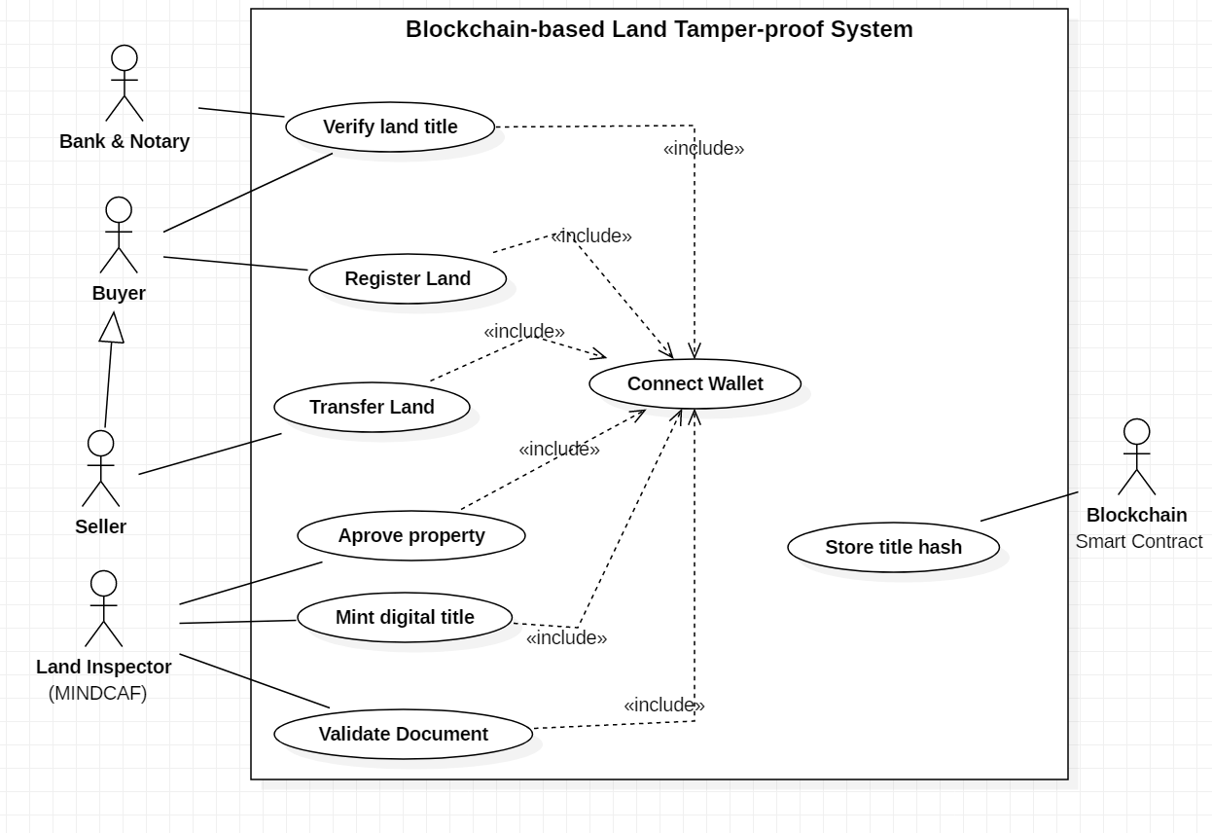
Figure 1 Usecase Analysis

3.5.6 Sequence Diagram(s)
Sequence diagrams illustrate how different components of the system interact during specific processes.
A typical land registration process involves:
- User submits land registration request.
- The frontend application sends transaction data to the smart contract.
- The smart contract validates the request.
- The blockchain records the transaction.
- The system returns confirmation to the user.
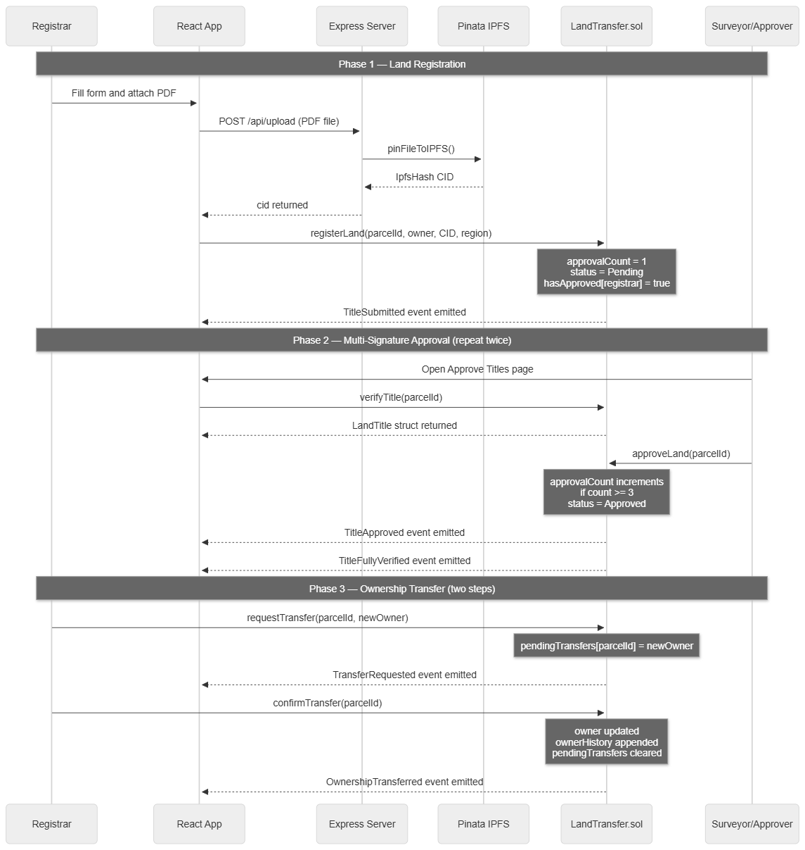
Figure 2 Sequence diagram to register and verify land title
The sequence diagram illustrates the interaction between system components during land registration and verification. Citizens upload land title documents which are stored on IPFS, while the blockchain records ownership and document hashes through smart contracts.

3.5.7 Activity Diagram
The activity diagram describes the process flow of land title registration, starting from document upload by the citizen to verification by the land inspector and final recording on the blockchain.
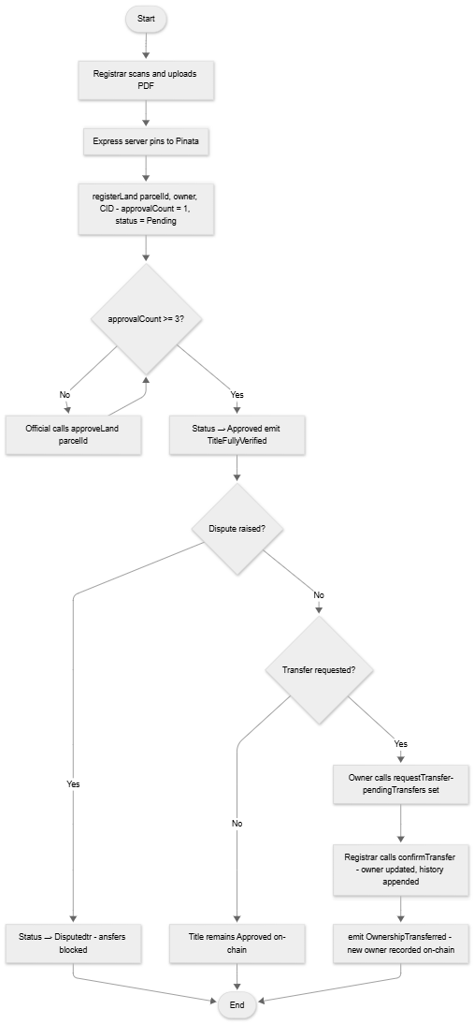
Figure 3 Activity diagram

3.6 System Design

3.6.1 System Architecture
The system follows a layered architecture that separates user interaction, application logic, blockchain operations, and data storage. This modular design improves scalability, security, and maintainability while ensuring that only verified land ownership records are stored on the blockchain.
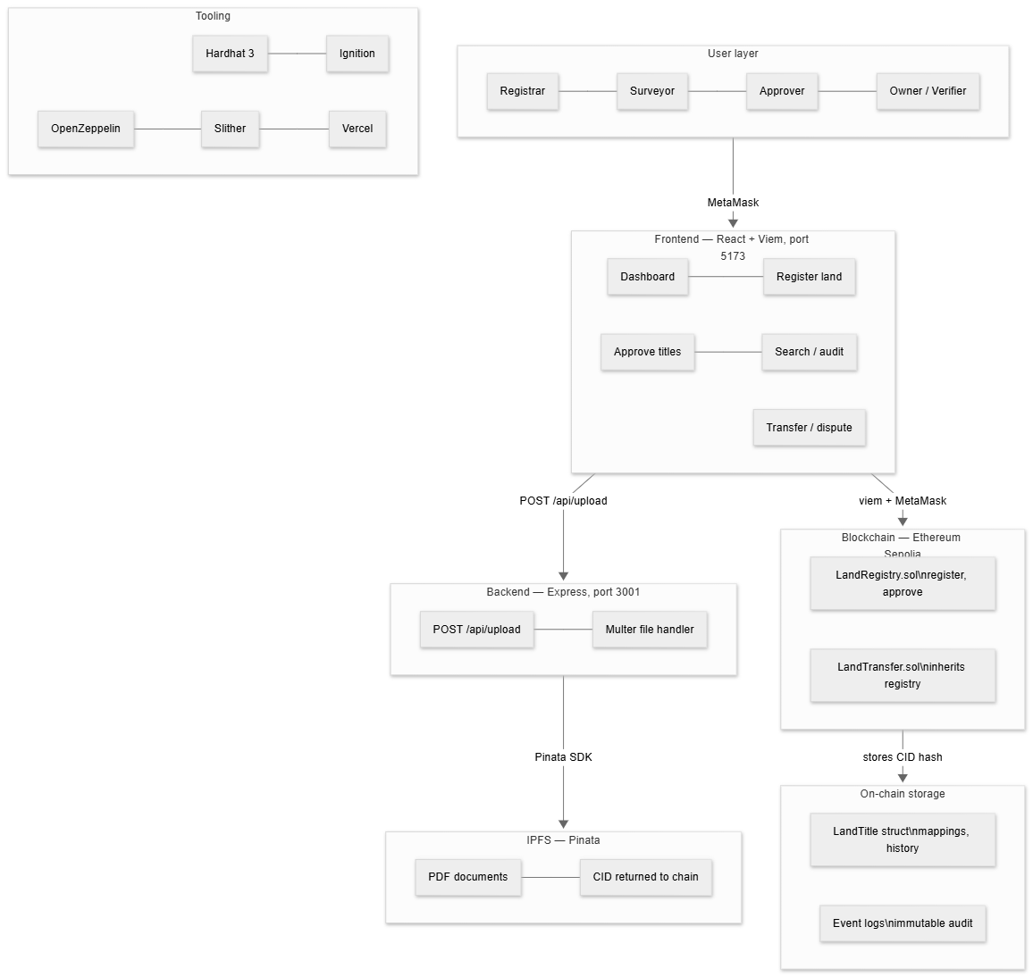
Figure 4 Achitecture diagram

3.6.3 Class Diagram
The class diagram represents the structural design of the system including user roles, land title records, and smart contract functions.
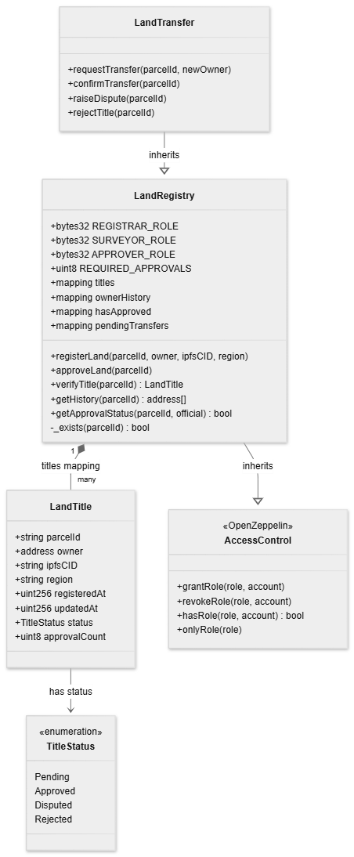
Figure 5 Class diagram

3.6.4 Entity-Relationship Diagram
The ER diagram shows relationships between users, land titles, and ownership transactions maintained by the application.
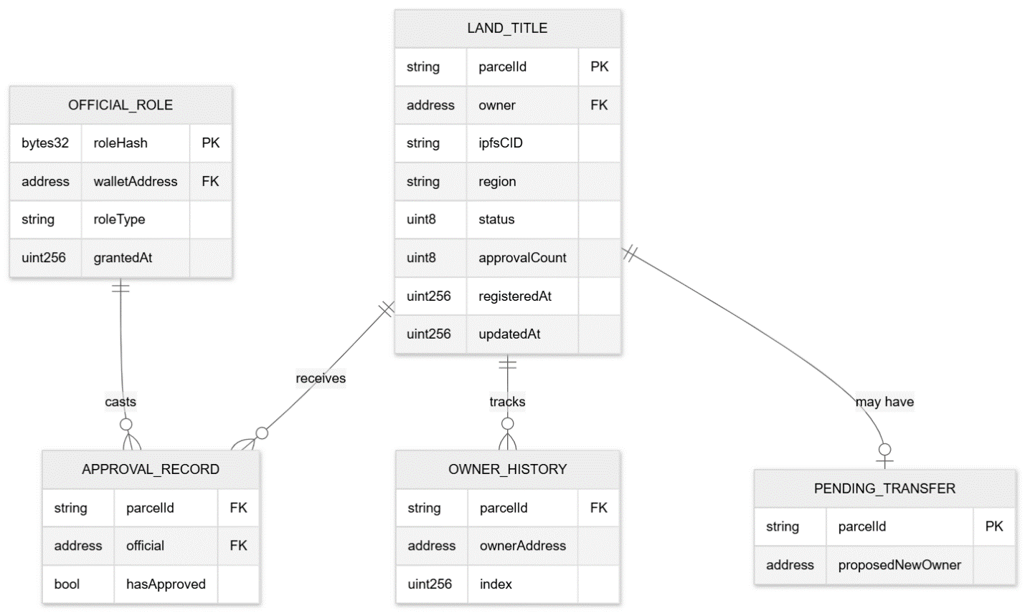
Figure 6 ER Diagram

3.6.5 Data Dictionary
Field | Type | Description
landID | String | Unique identifier for land property
ownerWallet | String | Blockchain wallet address of owner
documentCID | String | IPFS content identifier for title document
Status | String | Status of land claim (Pending/Approved/Rejected)
transactionID | String | Unique tranfer transaction identifier
transferDate | Date | Date of ownership transfer

